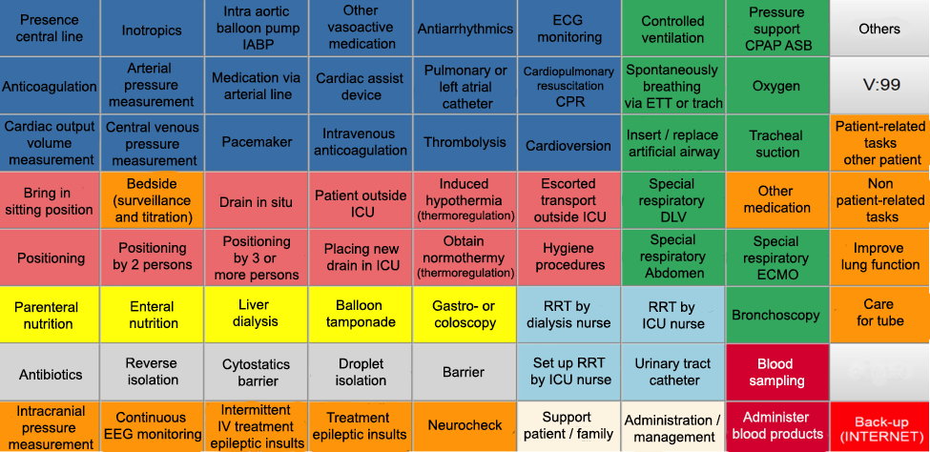
Additional Figure 1
Additional Figure 1. Interface of the web application used by observers during measurements. For each time a nurse started a task, the observer pressed the corresponding button for recording the start time. When a button is switched on, the color changes, which indicates the time of the specific task is recorded. When the nurse ends the activity, the button is switched off and records the time of ending.

